“Project Title”

A PROJECT REPORT
SUBMITTEDBY
HariKrushna (ET25IMCA008)
Aum (ET25IMCA039)
Yesh (ET25IMCA044)

UNDER THE GUIDANCEOF
Prof. Veer Pachchigar

In Fulfillment of subject Software Project[IMCA16212]
Of
IntegratedMasterofComputerApplications
At

SarvajanikCollegeofEngineeringandTechnology,Surat.
SarvajanikUniversity
May,2026

 | SarvajanikEducationSociety  SarvajanikCollegeofEngineering&Technology,Surat.  DepartmentofComputerApplications Academic Year:2025-26 | 

Date:

CERTIFICATE

This is to certify that the project entitled “AYH MART: Checkout System” has been submitted by HariKrushna (ET25IMCA008), Aum (ET25IMCA039), Yesh (ET25IMCA044) towards the fulfillment for the subject Software Project in C/C++ in 2nd Semester of IMCA of Sarvajanik University, Surat during the academic year 2025-2026.

Prof. Veer Pachchigar | Dr. Gayatri Kapadia (Head-Department of Computer  Applications)
(Guide’s Signature)

Examiner’sSignature
1.
2.

ACKNOWLEDGEMENT
We, the undersigned, would like to express our heartfelt gratitude and sincere appreciation to all those who played a pivotal role in the successful completion of this project — AYH Mart: A Self-Checkout Convenience Store Management System — developed as part of our academic curriculum at the undergraduate level.
First and foremost, we extend our deepest gratitude to our esteemed mentor, Veer Sir, whose patient guidance, constructive feedback, and unwavering encouragement proved invaluable throughout the course of this project. His insightful suggestions and expertise not only shaped the direction of this work but also motivated us to push beyond our perceived boundaries.
We are also deeply grateful to the faculty and administration of Sarvajanik College of Engineering and Technology, Surat, for providing us with an enriching academic environment, access to resources, and the opportunity to undertake practical projects that bridge theoretical knowledge with real-world applications.
This project was undertaken as part of our MCA (Integrated) program, and we are thankful to the department for including project-based learning as a core component of the curriculum, which allowed us to apply our programming skills in a meaningful, real-world context.
The AYH Mart project is inspired by the model of modern convenience stores, similar to 7-Eleven, adapted as a self-checkout-based store management system. Developed entirely in the C programming language, the system encompasses customer self-checkout, inventory management, membership tiers, sales reporting, and secure data persistence — reflecting our collective effort, dedication, and growing proficiency in software development.
We would also like to acknowledge the mutual support and collaboration within our team. Each member — Harikrushna, Aum, and Yash — brought unique strengths to this project, and it is through our combined effort and team spirit that AYH Mart has come to life.
Last but not least, we are grateful to our families and friends for their constant moral support and encouragement, which kept us motivated through every challenge.
We sincerely hope that this project serves as a useful and meaningful contribution to the field of practical software application development.
Group Members:
Harikrushna | MCA (Integrated)
Aum | MCA (Integrated)
Yash | MCA (Integrated)

Mentor: Veer Sir
Institution: Sarvajanik College of Engineering and Technology, Surat, India
Program: MCA (Integrated)

Guidelines for Documentation:

- Format: The student has to submit hard copy of the Project report in below specified format:
  - Print out should be taken on both sides of the page with single line spacing.
  - Use Times NewRomanofsize11fornormal text.

Index
Sr.No | Topic | PageNo
1. | Abstract
2. | Objective
3. | SourceCode
4. | Screenshots
5. | Testcases
6. | Conclusion
7. | References

PROJECT ABSTRACT

AYH MART CHECKOUT SYSTEM

AYH Mart is a console-based checkout system developed in C, designed for a retail store. It allows customers to independently browse products, add items to a cart, and complete purchases via Cash or UPI QR Code.

The system supports three user roles - Customer, Staff, and Admin - each with a dedicated portal. Key features include product inventory management, a tiered membership discount program (Silver, Gold, Platinum), customer account management, and a detailed sales reporting module.

All data is managed in-memory using C structures, making the system
lightweight, efficient, and fully functional as a retail management
solution.
Objective
• To develop a console-based retail checkout system using C

• To implement role-based access (Admin, Staff, Customer)

• To design an efficient inventory management system

• To enable customer self-checkout functionality

• To provide multiple payment options (Cash and UPI QR Code)

• To implement a membership system with tiered discounts (Silver, Gold, Platinum)

• To manage customer accounts and purchase records

• To generate sales reports and analytics

• To build a simple, fast, and user-friendly system using modular programming

1
C-Based System
Create a system using C programming
language

2
Implement user roles for customers
and staff
Role-based Access

3
Streamline inventory tracking and
management processes Inventory Management

SourceCode

/*
============================================================
AYH MART - SELF CHECKOUT SYSTEM
Developed By: Aum, Yesh, HariKrushna
Location: Surat, India
============================================================
*/

#include <stdio.h>
#include <string.h>
#include <ctype.h>
#include <stdlib.h>
#include <windows.h>
#include <conio.h>

#define MAX_ITEMS 100
#define MAX_MEMBERS 100
#define MAX_CART 50
#define MAX_CUSTOMERS 100
#define MAX_SALES 1000

#define MEMBER_ID_BASE 1000
#define TXID_BASE 1000

#define FILE_PRODUCTS "ayhmart_products.dat"
#define FILE_MEMBERS "ayhmart_members.dat"
#define FILE_CUSTOMERS "ayhmart_customers.dat"
#define FILE_SALES "ayhmart_sales.dat"
#define FILE_COUNTERS "ayhmart_counters.dat"

/* ------------------ ANSI COLOR CODES ------------------ */
#define RESET "\033[0m"
#define BOLD "\033[1m"

#define RED "\033[31m"
#define GREEN "\033[32m"
#define YELLOW "\033[33m"
#define BLUE "\033[34m"
#define MAGENTA "\033[35m"
#define CYAN "\033[36m"
#define WHITE "\033[37m"

#define BRED "\033[91m"
#define BGREEN "\033[92m"
#define BYELLOW "\033[93m"
#define BBLUE "\033[94m"
#define BMAGENTA "\033[95m"
#define BCYAN "\033[96m"
#define BWHITE "\033[97m"

#define BG_BLUE "\033[44m"
#define BG_GREEN "\033[42m"
#define BG_RED "\033[41m"

#define OK(msg) printf(" " BGREEN "[OK]" RESET " %s\n", msg)
#define ERR(msg) printf(" " BRED "[X]" RESET " %s\n", msg)
#define WARN(msg) printf(" " BYELLOW "[!]" RESET " %s\n", msg)

/* ------------------ CREDENTIALS ------------------ */
char ad_user[] = "admin";
char ad_pass[] = "admin";
char sf_user[] = "staff";
char sf_pass[] = "staff";

/* ------------------ FORWARD DECLARATIONS ------------------ */
void mainManu();
int isCustomerIdExists(int id);
int isProductCodeExists(int code);
int isProductNameExists(char name[], int excludeIndex);
int strEqualCI(const char *a, const char *b);
void flushInput();
int readInt(int *out);
void admin();
void adminDashboard();
void inventory();
void add();
void login();
void view();
void del();
void editProduct();
void info();
void cust();
void custView();
void members();
void addMembers();
void deleteMembers();
void viewMembers();
void search();
void addCart();
void viewCart();
void checkout();
void salesManu();
void salesSummary();
void staffSalesSummary();
void productSales();
void discountReport();
void recordSale(int code, char name[], int qty, float price, int custId);
float applyDiscount(int, float);
void billing(float finalAmount, int isQR);
void staff();
void inputPassword(char *password);
void showCustomerHistory(int custId);
void custManage();
void addCustomer();
void deleteCustomer();
void viewCustomers();
int customerLogin();
void viewMyCard();
void saveProducts();
void loadProducts();
void saveMembers();
void loadMembers();
void saveCustomers();
void loadCustomers();
void saveSales();
void loadSales();
void saveCounters();
void loadCounters();
void saveAllData();
void loadAllData();
void backupRestore();

int totalQRPayments = 0;
int totalCashPayments = 0;

/* ------------------ STRUCTURES ------------------ */
struct Product {
int pCode;
char pName[50];
float pPrice;
int pStock;
char pCategory[30];
} shop[MAX_ITEMS];
int nProducts = 0;

struct Member {
int mId;
char mName[50];
float mSpent;
char mTier[20];
float mDisc;
int mUsed;
} Members[MAX_MEMBERS];
int nMembers = 0;

struct CartItem {
int code;
char name[50];
float price;
int qty;
} cart[MAX_CART];
int cartCount = 0;

struct Sale {
int pCode;
char pName[50];
int qty;
float price;
float total;
int custId;
};
struct Sale sales[MAX_SALES];
int nSales = 0;
float totalRevenue = 0;
float totalDiscount = 0;
int totalBills = 0;

struct Customer {
int cId;
char cName[50];
char cPass[20];
char cPhone[15];
char cEmail[50];
int cMemberId;
} customers[MAX_CUSTOMERS];
int nCustomers = 0;
int custLoggedIn = 0;
int currentCustIdx = -1;

/* ------------------ STYLING HELPERS ------------------ */
void printLine() {
printf(CYAN " ============================================================" RESET "\n");
}
void printDash() {
printf(BLUE " ------------------------------------------------------------" RESET "\n");
}
void printHeader(const char *title) {
int i, len, totalWidth, leftPad;
len = (int)strlen(title);
totalWidth = 58;
leftPad = (totalWidth - len) / 2;

printf("\n");
printf(BOLD BCYAN " +");
for (i = 0; i < totalWidth; i++){
printf("=");
}
printf("+\n" RESET);

printf(BOLD BCYAN " |" RESET);
for (i = 0; i < leftPad; i++){
printf(" ");
}

printf(BOLD BWHITE "%s" RESET, title);
for (i = 0; i < totalWidth - len - leftPad; i++){
printf(" ");
}

printf(BOLD BCYAN "|\n" RESET);

printf(BOLD BCYAN " +");
for (i = 0; i < totalWidth; i++){
printf("=");
}

printf("+\n" RESET);
}

/* ------------------ UTILITY HELPERS ------------------ */
void flushInput() {
int c;
while ((c = getchar()) != '\n' && c != EOF);
}

int readInt(int *out) {
int result = scanf("%d", out);
if (result != 1) {
flushInput();
return 0;
}
return 1;
}

int strEqualCI(const char *a, const char *b) {
while (*a && *b) {
if (tolower((unsigned char)*a) != tolower((unsigned char)*b)){
return 0;
}
a++;
b++;
}
return *a == *b;
}

/* ------------------ MAIN ------------------ */
int main() {
SetConsoleOutputCP(CP_UTF8);

HANDLE hOut = GetStdHandle(STD_OUTPUT_HANDLE);
DWORD dwMode = 0;
GetConsoleMode(hOut, &dwMode);
SetConsoleMode(hOut, dwMode | ENABLE_VIRTUAL_TERMINAL_PROCESSING);

shop[0] = (struct Product){101, "Rice", 45.00, 80, "Grocery"};
shop[1] = (struct Product){102, "Milk", 25.00, 120, "Dairy"};
shop[2] = (struct Product){103, "Bread", 30.00, 60, "Bakery"};
shop[3] = (struct Product){104, "Shampoo", 90.00, 40, "Personal"};
shop[4] = (struct Product){105, "PenDrive", 350.00, 15, "Electronics"};
nProducts = 5;

customers[0] = (struct Customer){1, "aum", "123", "9876543210", "aum@email.com", 0};
customers[1] = (struct Customer){2, "hari", "123", "9876543211", "hari@email.com", 0};
customers[2] = (struct Customer){3, "yash", "123", "9876543212", "yash@email.com", 0};
nCustomers = 3;

loadAllData();
mainManu();
return 0;
}

/* ------------------ MAIN MENU ------------------ */
void mainManu() {
int choice;
while (1) {
system("cls");
printHeader("AYH MART | Surat, India");
printHeader("WELCOME");
printf(" " BGREEN "1." RESET " Customer Self-Checkout\n");
printf(" " BCYAN "2." RESET " Staff / Admin Login\n");
printf(" " BYELLOW "3." RESET " View Store Info\n");
printf(" " BRED "0." RESET " Exit Application\n");
printDash();
printf(" " BOLD "Enter your choice: " RESET);

if (!readInt(&choice)) {
WARN("Invalid input. Try again.");
system("pause");
continue;
}

switch (choice) {
case 1:
cust();
break;
case 2:
login();
break;
case 3:
info();
break;
case 0:
printHeader("Thank you for visiting AYH Mart!");
exit(0);
default:
WARN("Invalid option. Try again.");
system("pause");
}
}
}

/* ------------------ LOGIN ------------------ */
void login() {
char username[20], password[20];
system("cls");
printHeader("AYH MART | Surat, India");
printHeader("STAFF / ADMIN LOGIN");
printf(" " BCYAN "Username: " RESET);
scanf("%19s", username);
printf(" " BCYAN "Password: " RESET);
inputPassword(password);

if (strcmp(username, ad_user) == 0 && strcmp(password, ad_pass) == 0){
printf("\n");
OK("Logged in as " BMAGENTA "ADMIN");
system("pause");
adminDashboard();
}else if (strcmp(username, sf_user) == 0 && strcmp(password, sf_pass) == 0){
printf("\n");
OK("Logged in as " BCYAN "STAFF");
system("pause");
staff();
}else{
printf("\n");
ERR("Incorrect username or password.");
system("pause");
}
}

/* ------------------ ADMIN DASHBOARD ------------------ */
void adminDashboard() {
int choice;
while (1) {
system("cls");
printHeader("AYH MART | Surat, India");
printHeader("ADMIN PORTAL");
printf(" " BGREEN "1." RESET " Inventory\n");
printf(" " BCYAN "2." RESET " Members\n");
printf(" " BYELLOW "3." RESET " Sales Report\n");
printf(" " BBLUE "4." RESET " Customer Accounts\n");
printf(" " BMAGENTA "5." RESET " Backup & Restore Data\n");
printf(" " BRED "0." RESET " Logout\n");
printDash();
printf(" " BOLD "Enter your choice: " RESET);

if (!readInt(&choice)) {
WARN("Invalid input.");
system("pause");
continue;
}

switch (choice) {
case 1:
inventory();
break;
case 2:
members();
break;
case 3:
salesManu();
break;
case 4:
custManage();
break;
case 5:
backupRestore();
break;
case 0:
printf("\n");
OK("Logged out successfully.");
printf("\n");
system("pause");
return;
default:
WARN("Invalid option.");
system("pause");
}
}
}

/* ------------------ INVENTORY ------------------ */
void inventory() {
int choice;
while (1) {
system("cls");
printHeader("AYH MART | Surat, India");
printHeader("INVENTORY MANAGEMENT");
printf(" " BGREEN "1." RESET " Add Product(s)\n");
printf(" " BYELLOW "2." RESET " Edit Product\n");
printf(" " BRED "3." RESET " Delete Product\n");
printf(" " BCYAN "4." RESET " View All Products\n");
printf(" " BWHITE "0." RESET " Back\n");
printDash();
printf(" " BOLD "Enter your choice: " RESET);

if (!readInt(&choice)) {
WARN("Invalid input.");
system("pause");
continue;
}

switch (choice) {
case 1:
add();
break;
case 2:
editProduct();
break;
case 3:
del();
break;
case 4:
view();
break;
case 0:
return;
default:
WARN("Invalid option.");
system("pause");
}
}
}

/* ------------------ Add products ------------------ */
void add() {
int count, i;
system("cls");
printHeader("AYH MART | Surat, India");
printHeader("ADD PRODUCTS");
printf("\n How many products to add: ");

if (!readInt(&count) || count <= 0) {
WARN("Invalid count.");
system("pause");
return;
}

for (i = 0; i < count; i++) {
if (nProducts >= MAX_ITEMS) {
WARN("Product limit reached (" BYELLOW "100" RESET " max).");
system("pause");
return;
}
printf("\n " BOLD BCYAN "-- Product %d --" RESET "\n", i + 1);

int code;
while (1) {
printf(" Code : ");
if (!readInt(&code)) {
WARN("Invalid code. Try again.");
continue;
}
if (isProductCodeExists(code)) {
WARN("Product code already exists. Enter different code.");
} else {
shop[nProducts].pCode = code;
break;
}
}

char tempName[50];
while (1) {
printf(" Name : ");
scanf(" %49s", tempName);
if (isProductNameExists(tempName, -1)) {
WARN("Product with this name already exists. Enter different name.");
} else {
strcpy(shop[nProducts].pName, tempName);
break;
}
}

printf(" Price : ");
scanf("%f", &shop[nProducts].pPrice);
printf(" Stock : ");
if (!readInt(&shop[nProducts].pStock)) shop[nProducts].pStock = 0;
printf(" Category: ");
scanf("%29s", shop[nProducts].pCategory);
nProducts++;
}
printf("\n");
printf(" " BGREEN "[OK]" RESET " " BGREEN "%d" RESET " product(s) added successfully.\n", count);
saveProducts();
system("pause");
}

/* ------------------ Edit product ------------------ */
void editProduct() {
int code, found = 0, i;
printf("\n Enter Product Code to Edit: ");
if (!readInt(&code)) {
WARN("Invalid code.");
system("pause");
return;
}

for (i = 0; i < nProducts; i++) {
if (shop[i].pCode == code) {
found = 1;
printf("\n Editing: " BYELLOW "%s" RESET "\n", shop[i].pName);
printf(" Leave field blank / enter 0 to keep current value.\n\n");

char buf[50];
float fval;
int ival;

while (1) {
printf(" New Name [" BCYAN "%s" RESET "]: ", shop[i].pName);
scanf(" %49s", buf);
if (strcmp(buf, "0") == 0){
break;
}
if (isProductNameExists(buf, i)) {
WARN("Product with this name already exists. Try different name.");
} else {
strcpy(shop[i].pName, buf);
break;
}
}

printf(" New Price [" BCYAN "%.2f" RESET "]: ", shop[i].pPrice);
scanf("%f", &fval);
if (fval > 0) {
shop[i].pPrice = fval;
}

printf(" New Stock [" BCYAN "%d" RESET "]: ", shop[i].pStock);
if (readInt(&ival) && ival >= 0){
shop[i].pStock = ival;
}

printf(" New Category [" BCYAN "%s" RESET "]: ", shop[i].pCategory);
scanf(" %29s", buf);
if (strcmp(buf, "0") != 0){
strcpy(shop[i].pCategory, buf);
}

printf("\n");
OK("Product updated successfully.");
saveProducts();
break;
}
}
if (!found){
ERR("Product code not found.");
}
system("pause");
}

/* ------------------ View products ------------------ */
void view() {
int i;
system("cls");
printHeader("AYH MART | Surat, India");
printHeader("AVAILABLE PRODUCTS");
if (nProducts == 0) {
WARN("No products in inventory.");
} else {
printf(" " BOLD BYELLOW "%-6s %-18s %-8s %-6s %s" RESET "\n", "CODE", "NAME", "PRICE", "STOCK", "CATEGORY");
printDash();
for (i = 0; i < nProducts; i++) {
printf(" " BCYAN "%-6d" RESET " %-18s " BGREEN "%-8.2f" RESET " ", shop[i].pCode, shop[i].pName, shop[i].pPrice);
if (shop[i].pStock <= 5){
printf(BRED "%-6d" RESET " %s\n", shop[i].pStock, shop[i].pCategory);
}else{
printf(BGREEN "%-6d" RESET " %s\n", shop[i].pStock, shop[i].pCategory);
}
}
}
printf("\n");
system("pause");
}

/* ------------------ Delete product ------------------ */
void del() {
int code, found = 0, i, j;
printf("\n Enter Product Code to Delete: ");
if (!readInt(&code)) {
WARN("Invalid code.");
system("pause");
return;
}

for (i = 0; i < nProducts; i++) {
if (shop[i].pCode == code) {
for (j = i; j < nProducts - 1; j++){
shop[j] = shop[j + 1];
}
nProducts--;
found = 1;
OK("Product deleted successfully.");
saveProducts();
break;
}
}
if (!found){
ERR("Product code not found.");
}
system("pause");
}

/* ------------------ STORE INFO ------------------ */
void info() {
system("cls");
printHeader("AYH MART | Surat, India");
printHeader("STORE INFORMATION");
printf(" " BCYAN "Store Name : " RESET "AYH Mart\n");
printf(" " BCYAN "Location : " RESET "Surat, India\n");
printf(" " BCYAN "Timing : " RESET "9 AM - 10 PM (Mon-Sun)\n");
printf(" " BMAGENTA "Developed By : " RESET "Aum, Yesh, HariKrushna\n");
printLine();
system("pause");
}

/* ------------------ CUSTOMER LOGIN ------------------ */
int customerLogin() {
int id, i;
char pass[20];
system("cls");
printHeader("AYH MART | Surat, India");
printHeader("CUSTOMER LOGIN");
printf(" " BCYAN "Customer ID : " RESET);
if (!readInt(&id)) {
printf("\n");
ERR("Invalid ID.");
system("pause");
return -1;
}
printf(" " BCYAN "Password : " RESET);
inputPassword(pass);

for (i = 0; i < nCustomers; i++) {
if (customers[i].cId == id && strcmp(customers[i].cPass, pass) == 0) {
printf("\n");
printf(" " BGREEN "[OK]" RESET " Welcome, " BGREEN BOLD "%s" RESET "!\n", customers[i].cName);
system("pause");
custLoggedIn = 1;
currentCustIdx = i;
return i;
}
}
printf("\n");
ERR("Invalid Customer ID or Password.");
system("pause");
return -1;
}

/* ------------------ CUSTOMER MENU ------------------ */
void cust() {
int choice, i;

if (!custLoggedIn) {
if (customerLogin() == -1) {
return;
}
}

while (1) {
system("cls");
printHeader("AYH MART | Surat, India");
printHeader("CUSTOMER SELF-CHECKOUT");
printf(" Welcome, " BGREEN BOLD "%s" RESET "\n", customers[currentCustIdx].cName);
printDash();
printf(" " BCYAN "1." RESET " View Store Products\n");
printf(" " BCYAN "2." RESET " Search for a Product\n");
printf(" " BGREEN "3." RESET " Add Item to Basket\n");
printf(" " BYELLOW "4." RESET " View My Basket\n");
printf(" " BMAGENTA "5." RESET " Final Checkout\n");
printf(" " BBLUE "6." RESET " My Membership Card\n");
printf(" " BRED "0." RESET " Logout & Return to Main Menu\n");
printDash();
printf(" " BOLD "Enter your choice: " RESET);

if (!readInt(&choice)) {
WARN("Invalid input.");
system("pause");
continue;
}

switch (choice) {
case 1:
custView();
break;
case 2:
search();
break;
case 3:
system("cls");
printHeader("AYH MART | Surat, India");
printHeader("ADD ITEM TO BASKET");
if (nProducts == 0) {
WARN("No products available.");
} else {
printf(" " BOLD BYELLOW "%-6s %-18s %-8s %-6s %s" RESET "\n", "CODE", "NAME", "PRICE", "STOCK", "CATEGORY");
printDash();
for (i = 0; i < nProducts; i++) {
printf(" " BCYAN "%-6d" RESET " %-18s " BGREEN "%-8.2f" RESET " %-6d %s\n", shop[i].pCode, shop[i].pName, shop[i].pPrice, shop[i].pStock, shop[i].pCategory);
}
}
addCart();
break;
case 4:
viewCart();
break;
case 5:
checkout();
return;
case 6:
viewMyCard();
break;
case 0:
custLoggedIn = 0;
currentCustIdx = -1;
return;
default:
WARN("Invalid option.");
system("pause");
}
}
}

/* ------------------ Customer view ------------------ */
void custView() {
int i;
system("cls");
printHeader("AYH MART | Surat, India");
printHeader("AVAILABLE PRODUCTS");
if (nProducts == 0) {
WARN("No products available.");
} else {
printf(" " BOLD BYELLOW "%-6s %-18s %-8s %-6s %s" RESET "\n", "CODE", "NAME", "PRICE", "STOCK", "CATEGORY");
printDash();
for (i = 0; i < nProducts; i++) {
printf(" " BCYAN "%-6d" RESET " %-18s " BGREEN "%-8.2f" RESET " %-6d %s\n", shop[i].pCode, shop[i].pName, shop[i].pPrice, shop[i].pStock, shop[i].pCategory);
}
}
printf("\n");
system("pause");
}

/* ------------------ Search ------------------ */
void search() {
int code, found = 0, i;
system("cls");
printHeader("AYH MART | Surat, India");
printHeader("SEARCH PRODUCT");
printf("\n Enter Product Code to Search: ");
if (!readInt(&code)) {
WARN("Invalid code.");
system("pause");
return;
}

for (i = 0; i < nProducts; i++) {
if (shop[i].pCode == code) {
printDash();
printf(" " BGREEN "Found:\n" RESET);
printf(" " BCYAN "Product Name : " RESET "%s\n", shop[i].pName);
printf(" " BCYAN "Product Price : " RESET BGREEN "%.2f\n" RESET, shop[i].pPrice);
printf(" " BCYAN "Product Stock : " RESET "%d\n", shop[i].pStock);
printf(" " BCYAN "Product Category : " RESET "%s\n", shop[i].pCategory);
printDash();
found = 1;
break;
}
}
if (!found){
ERR("Product not found.");
}
printf("\n");
system("pause");
}

/* ------------------ Add to cart ------------------ */
void addCart() {
int code, qty, found = 0, i;
char confirm[4];

if (cartCount >= MAX_CART) {
WARN("Cart is full!");
system("pause");
return;
}

printf("\n Enter Product Code : ");
if (!readInt(&code)) {
WARN("Invalid code.");
system("pause");
return;
}
printf(" Enter Quantity : ");
if (!readInt(&qty) || qty <= 0) {
WARN("Invalid quantity.");
system("pause");
return;
}

for (i = 0; i < nProducts; i++) {
if (shop[i].pCode == code) {
if (shop[i].pStock < qty) {
printf(" " BRED "[!]" RESET " Insufficient stock (available: " BYELLOW "%d" RESET ").\n", shop[i].pStock);
found = 1;
break;
}

printf("\n " BOLD BCYAN "+- Confirm Item ----------------------------+" RESET "\n");
printf(" " BCYAN "|" RESET " Name : " BWHITE "%-31s" RESET BCYAN "|" RESET "\n", shop[i].pName);
printf(" " BCYAN "|" RESET " Price : " BGREEN "%-5.2f" RESET " per unit " BCYAN "|" RESET "\n", shop[i].pPrice);
printf(" " BCYAN "|" RESET " Qty : %-31d" BCYAN "|" RESET "\n", qty);
printf(" " BCYAN "|" RESET " Total : " BYELLOW "%-5.2f" RESET " " BCYAN "|" RESET "\n", shop[i].pPrice * qty);
printf(" " BCYAN "+-------------------------------------------+" RESET "\n");
printf(" Add to cart? (yes/no): ");
scanf(" %3s", confirm);

if (strcmp(confirm, "yes") == 0 || strcmp(confirm, "y") == 0) {
cart[cartCount].code = shop[i].pCode;
strcpy(cart[cartCount].name, shop[i].pName);
cart[cartCount].price = shop[i].pPrice;
cart[cartCount].qty = qty;
shop[i].pStock -= qty;
saveProducts();
cartCount++;
OK("Item added to basket.");
} else {
printf(" " BYELLOW "[-]" RESET " Item not added.\n");
}
found = 1;
break;
}
}
if (!found) ERR("Product unavailable.");
printf("\n");
system("pause");
}

/* ------------------ View cart ------------------ */
void viewCart() {
float total = 0;
int i;
system("cls");
printHeader("AYH MART | Surat, India");
printHeader("MY BASKET");
if (cartCount == 0) {
WARN("Basket is empty.");
} else {
printf(" " BOLD BYELLOW "%-6s %-18s %-8s %-5s %s" RESET "\n",
"CODE", "NAME", "PRICE", "QTY", "AMOUNT");
printDash();
for (i = 0; i < cartCount; i++) {
float amt = cart[i].price * cart[i].qty;
total += amt;
printf(" " BCYAN "%-6d" RESET " %-18s " BGREEN "%-8.2f" RESET " %-5d " BGREEN "%.2f" RESET "\n", cart[i].code, cart[i].name, cart[i].price, cart[i].qty, amt);
}
printDash();
printf(" " BOLD "%-40s " BYELLOW "%.2f" RESET "\n", "Grand Total:", total);
}
printf("\n");
system("pause");
}

/* ------------------ PRINT QR CODE ------------------ */
void printQRCode() {
printf(BWHITE);
printf(" +----------------------------------------------------------+\n");
printf(" | |\n");
printf(" | ############## ## ## #### #### ############## |\n");
printf(" | ## ## #### ## #### ## ## |\n");
printf(" | ## ###### ## ## ######## #### ## ###### ## |\n");
printf(" | ## ###### ## #### ## ## ## ## ###### ## |\n");
printf(" | ## ###### ## ## ## #### #### ## ###### ## |\n");
printf(" | ## ## #### ###### #### ## ## |\n");
printf(" | ############## ## ## ## ## ## ############## |\n");
printf(" | ## #### ## #### |\n");
printf(" | #### ######## #### ###### #### #### ###### |\n");
printf(" | ## #### ## ## ## ## ## ###### ## |\n");
printf(" | ###### ## #### ## ## ## #### ## ## ## |\n");
printf(" | ## #### ###### ###### ## ###### ###### ## |\n");
printf(" | ## ## ## ###### ## ## ## ## #### #### |\n");
printf(" | ###### ######## #### ## #### ###### ## |\n");
printf(" | ## ## ## #### ###### ## #### #### ###### |\n");
printf(" | #### ###### ## ## ## ## ## ######## ## ## |\n");
printf(" | ## ## ######## #### ###### ## ## #### |\n");
printf(" | ###### ###### ## ## ###### #### ## ######## |\n");
printf(" | ## ## ## #### #### ## ## ###### ## ## |\n");
printf(" | #### ###### ## ###### #### #### ## #### ## |\n");
printf(" | ###### #### ## ## ## ## |\n");
printf(" | ############## #### ## ###### ## ## ###### |\n");
printf(" | ## ## ## ###### #### ###### ## ## |\n");
printf(" | ## ###### ## #### ## ###### ################ |\n");
printf(" | ## ###### ## ## ###### ## ######## ###### |\n");
printf(" | ## ###### ## ###### ## ## ## ## ## #### |\n");
printf(" | ## ## #### ## ###### #### ## ## |\n");
printf(" | ############## ## ###### ## ######## ## ## |\n");
printf(" | |\n");
printf(" +----------------------------------------------------------+\n");
printf(RESET);
}

/* ------------------ Checkout ------------------ */
void checkout() {
int mid, i, payChoice;
float subtotal = 0, discount = 0, finalAmount;
system("cls");
printHeader("AYH MART | Surat, India");
printHeader("CHECKOUT");
if (cartCount == 0) {
WARN("Basket is empty.");
system("pause");
return;
}

for (i = 0; i < cartCount; i++){
subtotal += cart[i].price * cart[i].qty;
}

printf("\n Enter Member ID (0 if none): ");
if (!readInt(&mid)){
mid = 0;
}

discount = applyDiscount(mid, subtotal);
finalAmount = subtotal - discount;

printDash();
printf(" " BCYAN "Subtotal : " RESET "%.2f\n", subtotal);
printf(" " BGREEN "Discount : " RESET BGREEN "%.2f\n" RESET, discount);
printf(" " BOLD BYELLOW "Payable Amount : %.2f\n" RESET, finalAmount);
printDash();

printf("\n " BOLD "SELECT PAYMENT METHOD:\n" RESET);
printf(" " BWHITE "1." RESET " Cash\n");
printf(" " BCYAN "2." RESET " QR Code (Digital)\n");
printf(" Enter choice: ");
if (!readInt(&payChoice)) payChoice = 1;

for (i = 0; i < cartCount; i++) {
recordSale(cart[i].code, cart[i].name, cart[i].qty, cart[i].price, customers[currentCustIdx].cId);
}

totalBills++;
cartCount = 0;
custLoggedIn = 0;
currentCustIdx = -1;
saveAllData();

if (payChoice == 2) {
printf("\n " BCYAN "[ SCAN QR CODE TO PAY - Dhameliya Yash Mukeshbhai ]\n\n" RESET);
printQRCode();
printf("\n " BCYAN "UPI ID : " RESET "6353999107@ptyes\n");
printf(" " BYELLOW "Amount : Rs. %.2f\n\n" RESET, finalAmount);
totalQRPayments++;
saveCounters();
billing(finalAmount, 1);
} else {
totalCashPayments++;
saveCounters();
billing(finalAmount, 0);
}
}

/* ------------------ Show customer purchase history ------------------ */
void showCustomerHistory(int custId) {
int i, found = 0;
float totalSpent = 0;

printf("\n " BOLD BYELLOW "===== CUSTOMER PURCHASE HISTORY =====" RESET "\n");
printf(" " BOLD "%-6s %-18s %-5s %s\n" RESET, "CODE", "NAME", "QTY", "TOTAL");
printDash();

for (i = 0; i < nSales; i++) {
if (sales[i].custId == custId) {
printf(" " BCYAN "%-6d" RESET " %-18s %-5d " BGREEN "%.2f\n" RESET, sales[i].pCode, sales[i].pName, sales[i].qty, sales[i].total);
totalSpent += sales[i].total;
found = 1;
}
}

if (!found) {
WARN("No purchase history found.");
} else {
printDash();
printf(" " BOLD "Total Spent: " BYELLOW "%.2f\n" RESET, totalSpent);
}
printDash();
}

/* ------------------ Billing ------------------ */
void billing(float finalAmount, int isQR) {
if (isQR) {
printLine();
printf(" " BCYAN "Transaction ID: " RESET BWHITE "AYH%d\n" RESET, TXID_BASE + totalBills);
printf(" " BGREEN BOLD "Thank you for shopping at AYH Mart!\n" RESET);
printLine();
system("pause");
return;
}

float payAmount;
while (1) {
printf(" Pay by Cash (enter amount): ");
scanf("%f", &payAmount);

if (payAmount >= finalAmount) {
float change = payAmount - finalAmount;
printf("\n");
printLine();
printf(" " BGREEN "[OK]" RESET " Payment received! Change: " BYELLOW "%.2f\n" RESET, change);
printf(" " BGREEN BOLD "Thank you for shopping at AYH Mart!\n" RESET);
printLine();
system("pause");
return;
} else {
printf(" " BRED "[!]" RESET " Insufficient. Need " BYELLOW "%.2f" RESET " more.\n", finalAmount - payAmount);
}
}
}

/* ------------------ MEMBERS ------------------ */
void members() {
int choice;
while (1) {
system("cls");
printHeader("AYH MART | Surat, India");
printHeader("MEMBER PORTAL");
printf(" " BGREEN "1." RESET " Add New Member\n");
printf(" " BRED "2." RESET " Delete Member\n");
printf(" " BCYAN "3." RESET " View All Members\n");
printf(" " BWHITE "0." RESET " Back\n");
printDash();
printf(" " BOLD "Enter your choice: " RESET);

if (!readInt(&choice)) {
WARN("Invalid input.");
system("pause");
continue;
}

switch (choice) {
case 1:
addMembers();
break;
case 2:
deleteMembers();
break;
case 3:
viewMembers();
break;
case 0:
return;
default:
WARN("Invalid option.");
system("pause");
}
}
}

/* ------------------ Add members ------------------ */
void addMembers() {
int count, i, j;
system("cls");
printHeader("AYH MART | Surat, India");
printHeader("ADD MEMBERS");

printf("\n " BOLD BYELLOW "===== EXISTING CUSTOMER LIST =====" RESET "\n");

if (nCustomers == 0) {
WARN("No customers available. Please create customer first.");
system("pause");
return;
}

printf(" " BOLD "%-6s %-18s %s\n" RESET, "ID", "NAME", "MEMBER ID");
printDash();

for (i = 0; i < nCustomers; i++) {
if (customers[i].cMemberId == 0){
printf(" " BCYAN "%-6d" RESET " %-18s " BYELLOW "None\n" RESET, customers[i].cId, customers[i].cName);
}
else{
printf(" " BCYAN "%-6d" RESET " %-18s " BGREEN "%d\n" RESET, customers[i].cId, customers[i].cName, customers[i].cMemberId);
}
}
printDash();

printf("\n How many members to add: ");
if (!readInt(&count) || count <= 0) {
WARN("Invalid count.");
system("pause");
return;
}

int added = 0;
while (added < count) {
if (nMembers >= MAX_MEMBERS) {
WARN("Member limit reached.");
break;
}

int custId, custIndex = -1;
char tier[20];

printf("\n " BOLD BCYAN "-- Member %d --" RESET "\n", added + 1);
printf(" Enter Customer ID to assign membership: ");
if (!readInt(&custId)) {
WARN("Invalid ID. Try again.");
continue;
}

for (j = 0; j < nCustomers; j++) {
if (customers[j].cId == custId) { custIndex = j; break; }
}

if (custIndex == -1) {
ERR("Customer not found.");
continue;
}

showCustomerHistory(customers[custIndex].cId);

printf("\n Continue to assign membership? (yes/no): ");
char confirm[5];
scanf("%4s", confirm);

if (strcmp(confirm, "yes") != 0 && strcmp(confirm, "y") != 0) {
printf(" " BYELLOW "Skipped.\n" RESET);
continue;
}

if (customers[custIndex].cMemberId != 0) {
WARN("This customer already has a membership.");
continue;
}

Members[nMembers].mId = MEMBER_ID_BASE + nMembers;
strcpy(Members[nMembers].mName, customers[custIndex].cName);

printf(" Assigned to: " BGREEN "%s\n" RESET, customers[custIndex].cName);
printf(" Generated Member ID: " BCYAN "%d\n" RESET, Members[nMembers].mId);

printf(" Amount Spent: ");
scanf("%f", &Members[nMembers].mSpent);

while (1) {
printf(" Tier (" BYELLOW "Silver/s" RESET " | " BMAGENTA "Gold/g" RESET " | " BCYAN "Platinum/p" RESET "): ");
scanf("%19s", tier);
char c = tolower((unsigned char)tier[0]);
if (c == 's') {
strcpy(Members[nMembers].mTier, "Silver");
Members[nMembers].mDisc = 5.0f;
break;
} else if (c == 'g') {
strcpy(Members[nMembers].mTier, "Gold");
Members[nMembers].mDisc = 10.0f;
break;
} else if (c == 'p') {
strcpy(Members[nMembers].mTier, "Platinum");
Members[nMembers].mDisc = 15.0f;
break;
} else {
WARN("Invalid tier. Try again.");
}
}

Members[nMembers].mUsed = 0;
customers[custIndex].cMemberId = Members[nMembers].mId;
nMembers++;
added++;
}

printf("\n");
OK("Member(s) added and linked successfully.");
saveMembers();
saveCustomers();
system("pause");
}

/* ------------------ Delete member ------------------ */
void deleteMembers() {
int i, id, found = 0, j;
system("cls");
printHeader("AYH MART | Surat, India");
printHeader("DELETE MEMBER");
printf("\n Enter Member ID to Delete: ");
if (!readInt(&id)) {
WARN("Invalid ID.");
system("pause");
return;
}

for (i = 0; i < nMembers; i++) {
if (Members[i].mId == id) {
for (j = i; j < nMembers - 1; j++) Members[j] = Members[j + 1];
nMembers--;
found = 1;
OK("Member deleted.");
saveMembers();
break;
}
}
if (!found) ERR("Member ID not found.");
system("pause");
}

/* ------------------ View members ------------------ */
void viewMembers() {
int i;
system("cls");
printHeader("AYH MART | Surat, India");
printHeader("ALL MEMBERS");
if (nMembers == 0) {
WARN("No members registered.");
} else {
printf(" " BOLD BYELLOW "%-5s %-18s %-10s %-10s %-9s %s\n" RESET,
"ID", "NAME", "SPENT", "TIER", "DISCOUNT", "CARD STATUS");
printDash();
for (i = 0; i < nMembers; i++) {
const char *tierColor =
(Members[i].mTier[0] == 'P') ? BCYAN :
(Members[i].mTier[0] == 'G') ? BYELLOW : WHITE;
const char *statusColor = Members[i].mUsed ? BRED : BGREEN;

printf(" " BCYAN "%-5d" RESET " %-18s %-10.2f %s%-10s" RESET " %-9.0f%% %s%s" RESET "\n",
Members[i].mId, Members[i].mName, Members[i].mSpent,
tierColor, Members[i].mTier,
Members[i].mDisc,
statusColor, Members[i].mUsed ? "Used" : "Active");
}
}
printf("\n");
system("pause");
}

/* ------------------ CUSTOMER ACCOUNT MANAGEMENT ------------------ */
void custManage() {
int choice;
while (1) {
system("cls");
printHeader("AYH MART | Surat, India");
printHeader("CUSTOMER ACCOUNT MANAGEMENT");
printf(" " BGREEN "1." RESET " Add New Customer Account\n");
printf(" " BRED "2." RESET " Delete Customer Account\n");
printf(" " BCYAN "3." RESET " View All Customer Accounts\n");
printf(" " BWHITE "0." RESET " Back\n");
printDash();
printf(" " BOLD "Enter your choice: " RESET);

if (!readInt(&choice)) {
WARN("Invalid input.");
system("pause");
continue;
}

switch (choice) {
case 1: addCustomer(); break;
case 2: deleteCustomer(); break;
case 3: viewCustomers(); break;
case 0: return;
default:
WARN("Invalid option.");
system("pause");
}
}
}

/* ------------------ Add customer accounts ------------------ */
void addCustomer() {
int count, i;
char passConfirm[20];
system("cls");
printHeader("AYH MART | Surat, India");
printHeader("ADD CUSTOMER ACCOUNT");
printf("\n How many customer accounts to add: ");
if (!readInt(&count) || count <= 0) {
WARN("Invalid count.");
system("pause");
return;
}

for (i = 0; i < count; i++) {
if (nCustomers >= MAX_CUSTOMERS) {
WARN("Customer limit reached (100 max).");
break;
}
printf("\n " BOLD BCYAN "-- Customer Account %d --" RESET "\n", i + 1);

int id;
while (1) {
printf(" Customer ID : ");
if (!readInt(&id)) {
WARN("Invalid ID. Try again.");
continue;
}
if (isCustomerIdExists(id)) {
WARN("Customer ID already exists. Try again.");
} else {
customers[nCustomers].cId = id;
break;
}
}

printf(" Name : "); scanf("%49s", customers[nCustomers].cName);
printf(" Phone Number : "); scanf("%14s", customers[nCustomers].cPhone);
printf(" Email Address: "); scanf("%49s", customers[nCustomers].cEmail);

while (1) {
printf(" Password : ");
inputPassword(customers[nCustomers].cPass);
printf("\n Confirm Pwd : ");
inputPassword(passConfirm);
if (strcmp(customers[nCustomers].cPass, passConfirm) == 0) {
break;
} else {
WARN("Passwords do not match. Try again.");
}
}
printf("\n");

printf(" Member ID : (enter 0 if no membership) ");
if (!readInt(&customers[nCustomers].cMemberId))
customers[nCustomers].cMemberId = 0;
nCustomers++;
}
printf("\n");
OK("Customer account(s) created successfully.");
saveCustomers();
system("pause");
}

/* ------------------ Delete customer account ------------------ */
void deleteCustomer() {
int id, i, j, found = 0;
system("cls");
printHeader("AYH MART | Surat, India");
printHeader("DELETE CUSTOMER ACCOUNT");
printf("\n Enter Customer ID to Delete: ");
if (!readInt(&id)) {
WARN("Invalid ID.");
system("pause");
return;
}

for (i = 0; i < nCustomers; i++) {
if (customers[i].cId == id) {
for (j = i; j < nCustomers - 1; j++) customers[j] = customers[j + 1];
nCustomers--;
found = 1;
OK("Customer account deleted.");
saveCustomers();
break;
}
}
if (!found) ERR("Customer ID not found.");
system("pause");
}

/* ------------------ View all customer accounts ------------------ */
void viewCustomers() {
int i;
system("cls");
printHeader("AYH MART | Surat, India");
printHeader("ALL CUSTOMER ACCOUNTS");
if (nCustomers == 0) {
WARN("No customer accounts registered.");
} else {
printf(" " BOLD BYELLOW "%-6s %-15s %-12s %-15s %-25s %s\n" RESET,
"ID", "NAME", "PASSWORD", "PHONE", "EMAIL", "MEMBER ID");
printDash();
for (i = 0; i < nCustomers; i++) {
char masked[20];
int k, plen = (int)strlen(customers[i].cPass);
for (k = 0; k < plen && k < 12; k++) masked[k] = '*';
masked[plen < 12 ? plen : 12] = '\0';

if (customers[i].cMemberId != 0) {
printf(" " BCYAN "%-6d" RESET " %-15s " BYELLOW "%-12s" RESET " %-15s %-25s " BGREEN "%d\n" RESET,
customers[i].cId, customers[i].cName, masked,
customers[i].cPhone, customers[i].cEmail, customers[i].cMemberId);
} else {
printf(" " BCYAN "%-6d" RESET " %-15s " BYELLOW "%-12s" RESET " %-15s %-25s None\n",
customers[i].cId, customers[i].cName, masked,
customers[i].cPhone, customers[i].cEmail);
}
}
}
printf("\n");
system("pause");
}

/* ------------------ VIEW MY MEMBERSHIP CARD ------------------ */
void viewMyCard() {
int i, found = 0;
int linkedId = customers[currentCustIdx].cMemberId;

system("cls");
printHeader("AYH MART | Surat, India");
printHeader("MY MEMBERSHIP CARD");

printf(" " BCYAN "Account Holder : " RESET BWHITE BOLD "%s\n" RESET,
customers[currentCustIdx].cName);
printf(" " BCYAN "Customer ID : " RESET "%d\n", customers[currentCustIdx].cId);
printDash();

if (linkedId == 0) {
WARN("No membership card linked to your account.");
printf(" Please contact Staff or Admin to get one assigned.\n");
} else {
for (i = 0; i < nMembers; i++) {
if (Members[i].mId == linkedId) {
found = 1;
const char *tierColor =
(Members[i].mTier[0] == 'P') ? BCYAN :
(Members[i].mTier[0] == 'G') ? BYELLOW : WHITE;

printf(" " BCYAN "Member ID : " RESET "%d\n", Members[i].mId);
printf(" " BCYAN "Member Name : " RESET "%s\n", Members[i].mName);
printf(" " BCYAN "Tier : " RESET "%s%s" RESET "\n", tierColor, Members[i].mTier);
printf(" " BCYAN "Discount Rate : " RESET BGREEN "%.0f%%\n" RESET, Members[i].mDisc);
printf(" " BCYAN "Total Spent : " RESET "Rs. %.2f\n", Members[i].mSpent);
printf(" " BCYAN "Card Status : " RESET "%s\n",
Members[i].mUsed
? BRED "Used (discount already redeemed)" RESET
: BGREEN "Active (discount available)" RESET);
break;
}
}
if (!found) {
printf(" " BRED "[!]" RESET " Linked Member ID (" BYELLOW "%d" RESET ") not found in records.\n", linkedId);
printf(" Please contact Staff or Admin.\n");
}
}
printDash();
system("pause");
}

/* ------------------ SALES ------------------ */
void recordSale(int code, char name[], int qty, float price, int custId) {
if (nSales >= MAX_SALES) return;
sales[nSales].pCode = code;
sales[nSales].custId = custId;
strcpy(sales[nSales].pName, name);
sales[nSales].qty = qty;
sales[nSales].price = price;
sales[nSales].total = qty * price;
totalRevenue += sales[nSales].total;
nSales++;
}

float applyDiscount(int memberId, float billAmount) {
int i;
if (memberId == 0) return 0;

for (i = 0; i < nMembers; i++) {
if (Members[i].mId == memberId) {
if (Members[i].mUsed == 1) {
WARN("Membership card already used. No discount applied.");
return 0;
}
float discount = billAmount * (Members[i].mDisc / 100.0f);
Members[i].mSpent += (billAmount - discount);
totalDiscount += discount;
Members[i].mUsed = 1;
printf(" " BGREEN "[OK]" RESET " Membership discount applied ("
BGREEN "%.0f%%" RESET "). Card is now marked as " BRED "used" RESET ".\n",
Members[i].mDisc);
return discount;
}
}
WARN("Member ID not found. No discount applied.");
return 0;
}

/* ------------------ SALES MENU ------------------ */
void salesManu() {
int choice;
while (1) {
system("cls");
printHeader("AYH MART | Surat, India");
printHeader("SALES REPORT");
printf(" " BCYAN "1." RESET " Summary Report\n");
printf(" " BYELLOW "2." RESET " Product-wise Sales\n");
printf(" " BMAGENTA "3." RESET " Member Discount Report\n");
printf(" " BWHITE "0." RESET " Back\n");
printDash();
printf(" " BOLD "Enter choice: " RESET);

if (!readInt(&choice)) {
WARN("Invalid input.");
system("pause");
continue;
}

switch (choice) {
case 1: salesSummary(); break;
case 2: productSales(); break;
case 3: discountReport(); break;
case 0: return;
default:
WARN("Invalid option.");
system("pause");
}
}
}

void salesSummary() {
system("cls");
printHeader("AYH MART | Surat, India");
printHeader("SALES SUMMARY");
printf(" " BCYAN "Total Bills Generated : " RESET BWHITE "%d\n" RESET, totalBills);
printf(" " BCYAN "-- Cash Payments : " RESET "%d\n", totalCashPayments);
printf(" " BCYAN "-- QR Payments : " RESET "%d\n", totalQRPayments);
printf(" " BCYAN "Total Items Sold : " RESET "%d\n", nSales);
printf(" " BCYAN "Total Revenue : " RESET BGREEN "%.2f\n" RESET, totalRevenue);
printf(" " BCYAN "Total Discount Given : " RESET BYELLOW "%.2f\n" RESET, totalDiscount);
printf(" " BOLD BCYAN "Net Revenue : " RESET BOLD BGREEN "%.2f\n" RESET,
totalRevenue - totalDiscount);
printDash();
system("pause");
}

void staffSalesSummary() {
int i;
system("cls");
printHeader("AYH MART | Surat, India");
printHeader("SALES SUMMARY");
printf(" " BCYAN "Total Items Sold : " RESET "%d\n", nSales);
printf(" " BCYAN "Total Revenue : " RESET BGREEN "Rs. %.2f\n" RESET, totalRevenue);
printDash();

printf("\n " BOLD BYELLOW "ITEMS SOLD:\n" RESET);
if (nSales == 0) {
WARN("No sales recorded yet.");
} else {
printf("\n " BOLD "%-6s %-18s %-6s %s\n" RESET, "CODE", "NAME", "QTY", "TOTAL");
printDash();
for (i = 0; i < nSales; i++)
printf(" " BCYAN "%-6d" RESET " %-18s %-6d " BGREEN "Rs. %.2f\n" RESET,
sales[i].pCode, sales[i].pName, sales[i].qty, sales[i].total);
printDash();
}
printf("\n");
system("pause");
}

void productSales() {
int i;
system("cls");
printHeader("AYH MART | Surat, India");
printHeader("PRODUCT SALES REPORT");
if (nSales == 0) {
WARN("No sales recorded yet.");
} else {
printf(" " BOLD BYELLOW "%-6s %-18s %-6s %s\n" RESET, "CODE", "NAME", "QTY", "TOTAL");
printDash();
for (i = 0; i < nSales; i++)
printf(" " BCYAN "%-6d" RESET " %-18s %-6d " BGREEN "%.2f\n" RESET,
sales[i].pCode, sales[i].pName, sales[i].qty, sales[i].total);
}
printf("\n");
system("pause");
}

void discountReport() {
int i;
system("cls");
printHeader("AYH MART | Surat, India");
printHeader("MEMBER DISCOUNT REPORT");
if (nMembers == 0) {
WARN("No members recorded.");
} else {
printf(" " BOLD BYELLOW "%-5s %-18s %-10s %-10s %-9s %s\n" RESET,
"ID", "NAME", "SPENT", "TIER", "DISCOUNT", "CARD STATUS");
printDash();
for (i = 0; i < nMembers; i++) {
const char *tierColor =
(Members[i].mTier[0] == 'P') ? BCYAN :
(Members[i].mTier[0] == 'G') ? BYELLOW : WHITE;
const char *statusColor = Members[i].mUsed ? BRED : BGREEN;
printf(" " BCYAN "%-5d" RESET " %-18s %-10.2f %s%-10s" RESET " %-9.0f%% %s%s" RESET "\n",
Members[i].mId, Members[i].mName, Members[i].mSpent,
tierColor, Members[i].mTier, Members[i].mDisc,
statusColor, Members[i].mUsed ? "Used" : "Active");
}
}
printf("\n");
system("pause");
}

/* ------------------ STAFF PORTAL ------------------ */
void staff() {
int choice;
while (1) {
system("cls");
printHeader("AYH MART | Surat, India");
printHeader("STAFF PORTAL");
printf(" " BCYAN "1." RESET " View Inventory\n");
printf(" " BBLUE "2." RESET " View All Members\n");
printf(" " BGREEN "3." RESET " Add New Member\n");
printf(" " BRED "4." RESET " Remove Member\n");
printf(" " BYELLOW "5." RESET " View Sales Summary\n");
printf(" " BMAGENTA "6." RESET " Search Product\n");
printf(" " BWHITE "7." RESET " Customer Accounts\n");
printf(" " BRED "0." RESET " Logout\n");
printDash();
printf(" " BOLD "Enter your choice: " RESET);

if (!readInt(&choice)) {
WARN("Invalid input.");
system("pause");
continue;
}

switch (choice) {
case 1: {
int i;
system("cls");
printHeader("AYH MART | Surat, India");
printHeader("INVENTORY (Staff View)");
if (nProducts == 0) {
WARN("No products.");
} else {
printf(" " BOLD BYELLOW "%-6s %-18s %-8s %-6s %s\n" RESET,
"CODE", "NAME", "PRICE", "STOCK", "CATEGORY");
printDash();
for (i = 0; i < nProducts; i++)
printf(" " BCYAN "%-6d" RESET " %-18s " BGREEN "%-8.2f" RESET " %-6d %s\n",
shop[i].pCode, shop[i].pName, shop[i].pPrice,
shop[i].pStock, shop[i].pCategory);
}
printf("\n"); system("pause"); break;
}
case 2: {
int i;
system("cls");
printHeader("AYH MART | Surat, India");
printHeader("ALL MEMBERS (Staff View)");
if (nMembers == 0) {
WARN("No members registered.");
} else {
printf(" " BOLD BYELLOW "%-5s %-18s %-10s %-10s %-9s %s\n" RESET,
"ID", "NAME", "SPENT", "TIER", "DISCOUNT", "CARD STATUS");
printDash();
for (i = 0; i < nMembers; i++) {
const char *sc = Members[i].mUsed ? BRED : BGREEN;
printf(" " BCYAN "%-5d" RESET " %-18s %-10.2f %-10s %-9.0f%% %s%s" RESET "\n",
Members[i].mId, Members[i].mName,
Members[i].mSpent, Members[i].mTier,
Members[i].mDisc,
sc, Members[i].mUsed ? "Used" : "Active");
}
}
printf("\n"); system("pause"); break;
}
case 3: addMembers(); break;
case 4: deleteMembers(); break;
case 5: staffSalesSummary(); break;
case 6: {
int code, found = 0, i;
system("cls");
printHeader("AYH MART | Surat, India");
printHeader("SEARCH PRODUCT");
printf("\n Enter Product Code to Search: ");
if (!readInt(&code)) {
WARN("Invalid code.");
system("pause");
break;
}
for (i = 0; i < nProducts; i++) {
if (shop[i].pCode == code) {
printDash();
printf(" " BGREEN "Found:\n" RESET);
printf(" " BCYAN "Product Name : " RESET "%s\n", shop[i].pName);
printf(" " BCYAN "Product Price : " RESET BGREEN "%.2f\n" RESET, shop[i].pPrice);
printf(" " BCYAN "Product Stock : " RESET "%d\n", shop[i].pStock);
printf(" " BCYAN "Product Category : " RESET "%s\n", shop[i].pCategory);
printDash();
found = 1;
break;
}
}
if (!found) ERR("Product not found.");
printf("\n"); system("pause"); break;
}
case 7: {
int staffChoice;
while (1) {
system("cls");
printHeader("AYH MART | Surat, India");
printHeader("CUSTOMER ACCOUNT MANAGEMENT");
printf(" " BGREEN "1." RESET " Add New Customer Account\n");
printf(" " BRED "2." RESET " Delete Customer Account\n");
printf(" " BCYAN "3." RESET " View All Customer Accounts\n");
printf(" " BWHITE "0." RESET " Back\n");
printDash();
printf(" " BOLD "Enter your choice: " RESET);

if (!readInt(&staffChoice)) {
WARN("Invalid input.");
system("pause");
continue;
}

switch (staffChoice) {
case 1: addCustomer(); break;
case 2: deleteCustomer(); break;
case 3: viewCustomers(); break;
case 0: goto staffCustomerDone;
default:
WARN("Invalid option.");
system("pause");
}
}
staffCustomerDone:;
break;
}
case 0:
OK("Logged out.");
system("pause");
return;
default:
WARN("Invalid option.");
system("pause");
}
}
}

/* ------------------ FILE HANDLING ------------------ */
void saveProducts() {
FILE *fp = fopen(FILE_PRODUCTS, "wb");
if (!fp) { ERR("Could not save products."); return; }
fwrite(&nProducts, sizeof(int), 1, fp);
fwrite(shop, sizeof(struct Product), nProducts, fp);
fclose(fp);
}
void loadProducts() {
FILE *fp = fopen(FILE_PRODUCTS, "rb");
if (!fp) return;
fread(&nProducts, sizeof(int), 1, fp);
if (nProducts > MAX_ITEMS) nProducts = MAX_ITEMS;
fread(shop, sizeof(struct Product), nProducts, fp);
fclose(fp);
}
void saveMembers() {
FILE *fp = fopen(FILE_MEMBERS, "wb");
if (!fp) { ERR("Could not save members."); return; }
fwrite(&nMembers, sizeof(int), 1, fp);
fwrite(Members, sizeof(struct Member), nMembers, fp);
fclose(fp);
}
void loadMembers() {
FILE *fp = fopen(FILE_MEMBERS, "rb");
if (!fp) return;
fread(&nMembers, sizeof(int), 1, fp);
if (nMembers > MAX_MEMBERS) nMembers = MAX_MEMBERS;
fread(Members, sizeof(struct Member), nMembers, fp);
fclose(fp);
}
void saveCustomers() {
FILE *fp = fopen(FILE_CUSTOMERS, "wb");
if (!fp) { ERR("Could not save customers."); return; }
fwrite(&nCustomers, sizeof(int), 1, fp);
fwrite(customers, sizeof(struct Customer), nCustomers, fp);
fclose(fp);
}
void loadCustomers() {
FILE *fp = fopen(FILE_CUSTOMERS, "rb");
if (!fp) return;
fread(&nCustomers, sizeof(int), 1, fp);
if (nCustomers > MAX_CUSTOMERS) nCustomers = MAX_CUSTOMERS;
fread(customers, sizeof(struct Customer), nCustomers, fp);
fclose(fp);
}
void saveSales() {
FILE *fp = fopen(FILE_SALES, "wb");
if (!fp) { ERR("Could not save sales."); return; }
fwrite(&nSales, sizeof(int), 1, fp);
fwrite(sales, sizeof(struct Sale), nSales, fp);
fclose(fp);
}
void loadSales() {
FILE *fp = fopen(FILE_SALES, "rb");
if (!fp) return;
fread(&nSales, sizeof(int), 1, fp);
if (nSales > MAX_SALES) nSales = MAX_SALES;
fread(sales, sizeof(struct Sale), nSales, fp);
fclose(fp);
}
void saveCounters() {
FILE *fp = fopen(FILE_COUNTERS, "wb");
if (!fp) return;
fwrite(&totalRevenue, sizeof(float), 1, fp);
fwrite(&totalDiscount, sizeof(float), 1, fp);
fwrite(&totalBills, sizeof(int), 1, fp);
fwrite(&totalQRPayments, sizeof(int), 1, fp);
fwrite(&totalCashPayments, sizeof(int), 1, fp);
fclose(fp);
}
void loadCounters() {
FILE *fp = fopen(FILE_COUNTERS, "rb");
if (!fp) return;
fread(&totalRevenue, sizeof(float), 1, fp);
fread(&totalDiscount, sizeof(float), 1, fp);
fread(&totalBills, sizeof(int), 1, fp);
fread(&totalQRPayments, sizeof(int), 1, fp);
fread(&totalCashPayments, sizeof(int), 1, fp);
fclose(fp);
}
void saveAllData() {
saveProducts(); saveMembers(); saveCustomers(); saveSales(); saveCounters();
}
void loadAllData() {
loadProducts(); loadMembers(); loadCustomers(); loadSales(); loadCounters();
}

/* ------------------ Backup & Restore Menu ------------------ */
void backupRestore() {
int choice;
while (1) {
system("cls");
printHeader("AYH MART | Surat, India");
printHeader("BACKUP & RESTORE DATA");
printf(" Files are stored in the program directory.\n\n");
printf(" " BGREEN "1." RESET " Save All Data (Backup)\n");
printf(" " BCYAN "2." RESET " Load All Data (Restore)\n");
printf(" " BYELLOW "3." RESET " View Backup File Status\n");
printf(" " BWHITE "0." RESET " Back to Admin Portal\n");
printDash();
printf(" " BOLD "Enter your choice: " RESET);

if (!readInt(&choice)) {
WARN("Invalid input.");
system("pause");
continue;
}

switch (choice) {
case 1:
saveAllData();
printf("\n");
OK("All data saved successfully.");
printf(" Products -> " BCYAN "%s\n" RESET, FILE_PRODUCTS);
printf(" Members -> " BCYAN "%s\n" RESET, FILE_MEMBERS);
printf(" Customers -> " BCYAN "%s\n" RESET, FILE_CUSTOMERS);
printf(" Sales -> " BCYAN "%s\n" RESET, FILE_SALES);
printf(" Counters -> " BCYAN "%s\n" RESET, FILE_COUNTERS);
printf("\n"); system("pause"); break;
case 2: {
char confirm[5];
printf("\n " BRED "[!]" RESET " This will overwrite current in-memory data.\n");
printf(" Are you sure? (yes/no): ");
scanf("%4s", confirm);
if (strcmp(confirm, "yes") == 0 || strcmp(confirm, "y") == 0) {
loadAllData();
OK("Data restored from files.");
printf(" Products : " BGREEN "%d loaded\n" RESET, nProducts);
printf(" Members : " BGREEN "%d loaded\n" RESET, nMembers);
printf(" Customers : " BGREEN "%d loaded\n" RESET, nCustomers);
printf(" Sales : " BGREEN "%d loaded\n" RESET, nSales);
} else {
printf(" " BYELLOW "[-]" RESET " Restore cancelled.\n");
}
printf("\n"); system("pause"); break;
}
case 3: {
FILE *fp;
system("cls");
printHeader("AYH MART | Surat, India");
printHeader("BACKUP FILE STATUS");
printf(" " BOLD "%-30s %s\n" RESET, "File", "Status");
printDash();
#define CHECK_FILE(f) \
fp = fopen(f, "rb"); \
printf(" %-30s %s\n", f, fp ? BGREEN "EXISTS" RESET : BRED "NOT FOUND" RESET); \
if (fp) fclose(fp);
CHECK_FILE(FILE_PRODUCTS)
CHECK_FILE(FILE_MEMBERS)
CHECK_FILE(FILE_CUSTOMERS)
CHECK_FILE(FILE_SALES)
CHECK_FILE(FILE_COUNTERS)
#undef CHECK_FILE
printf("\n"); system("pause"); break;
}
case 0: return;
default:
WARN("Invalid option.");
system("pause");
}
}
}

/* ------------------ Password input with masking ------------------ */
void inputPassword(char *password) {
int i = 0;
char ch;
while (1) {
ch = getch();
if (ch == 13) {
password[i] = '\0';
break;
} else if (ch == 8) {
if (i > 0) { i--; printf("\b \b"); }
} else {
password[i++] = ch;
printf(BMAGENTA "*" RESET);
}
}
}

/* ------------------ Check if product code exists ------------------ */
int isProductCodeExists(int code) {
int i;
for (i = 0; i < nProducts; i++)
if (shop[i].pCode == code) return 1;
return 0;
}

/* ------------------ Check if product name exists (case-insensitive) ------------------ */
int isProductNameExists(char name[], int excludeIndex) {
int i;
for (i = 0; i < nProducts; i++) {
if (i == excludeIndex) continue;
if (strEqualCI(shop[i].pName, name)) return 1;
}
return 0;
}

/* ------------------ Check if customer ID exists ------------------ */
int isCustomerIdExists(int id) {
int i;
for (i = 0; i < nCustomers; i++)
if (customers[i].cId == id) return 1;
return 0;
}

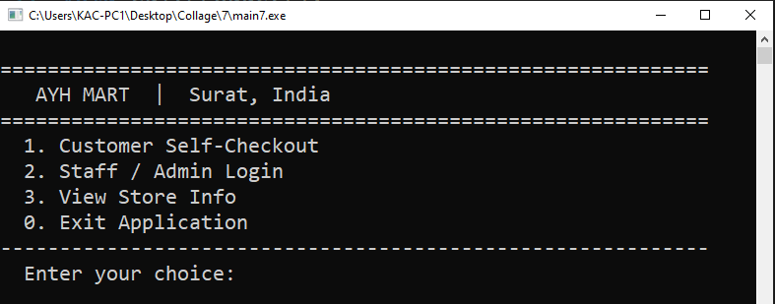
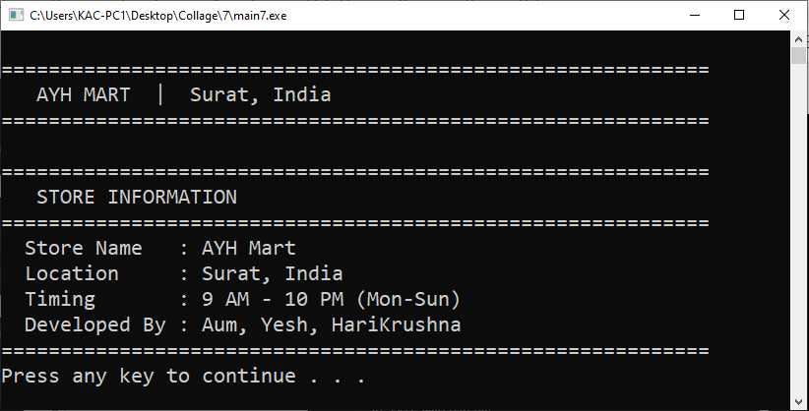
Main menu
View Store Info
Screenshot

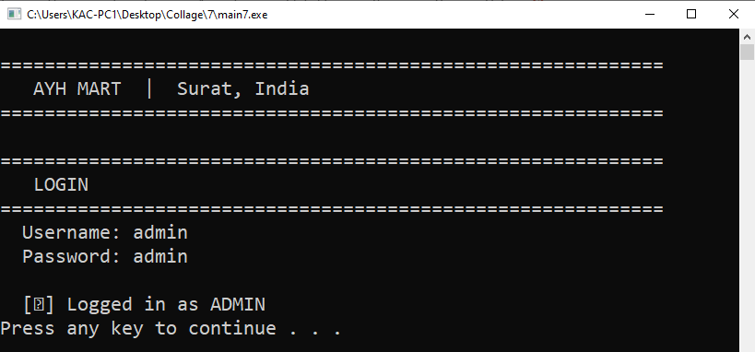
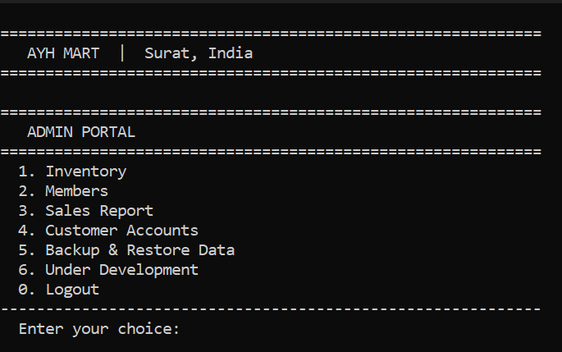
Admin Login
Admin Portal

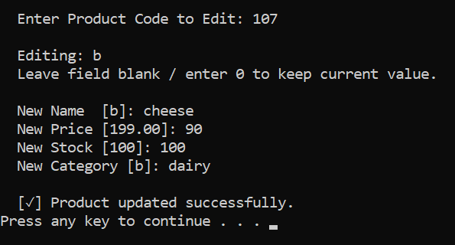
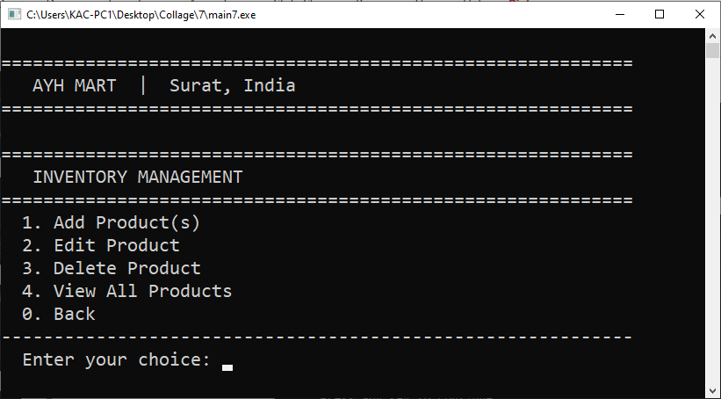
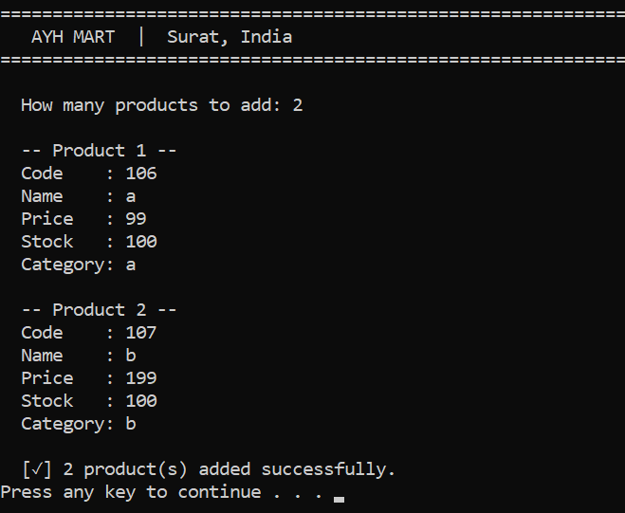
Edit Product
Inventory Management
Add Product(s)

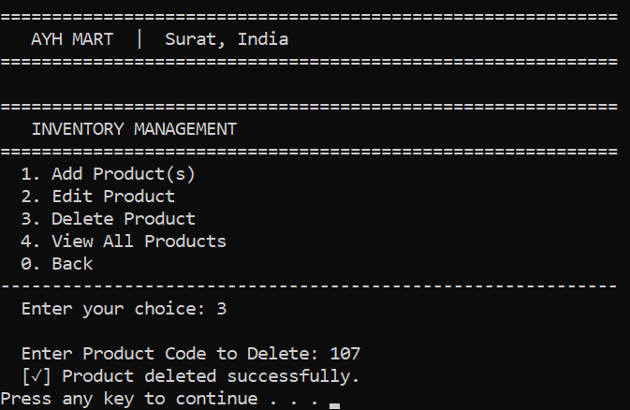
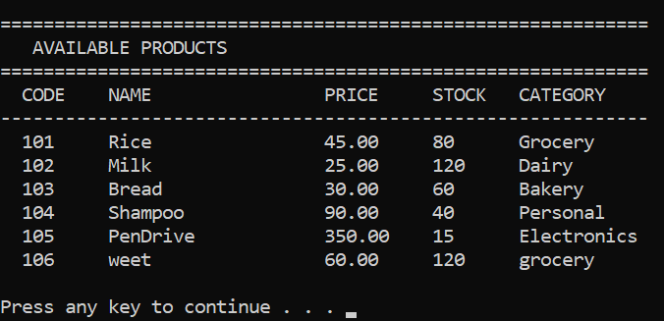
Delete Product
View all Product

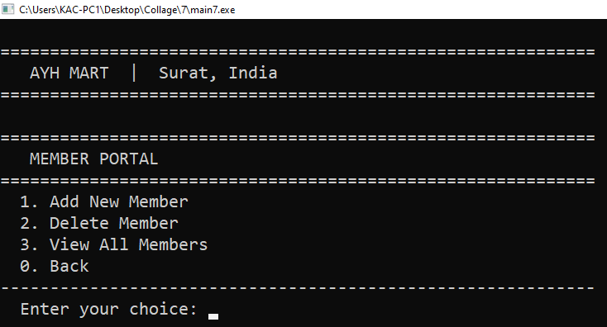
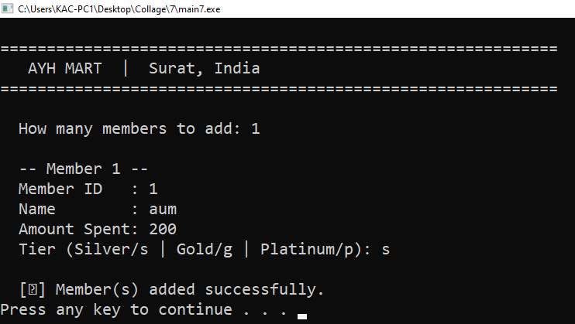
Member Portal
Add New Member

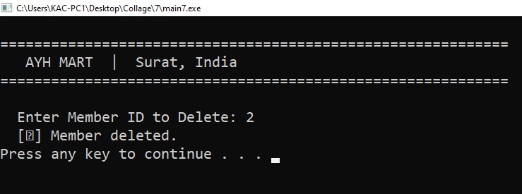
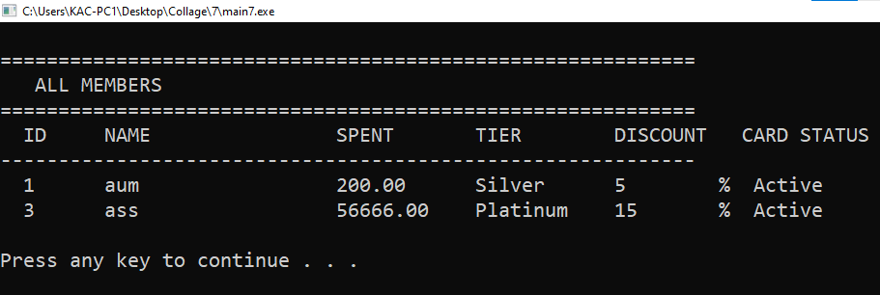
Delete Member
View all Member

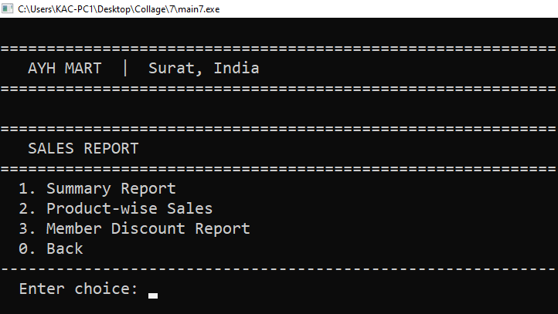
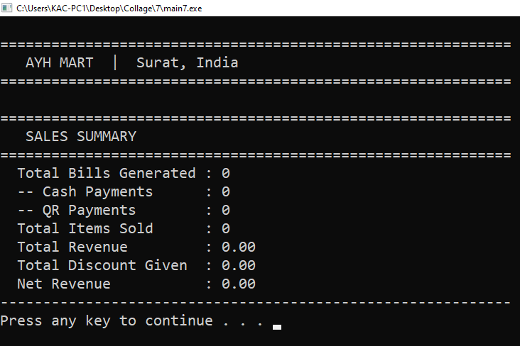
Sales Report
Sale Summary

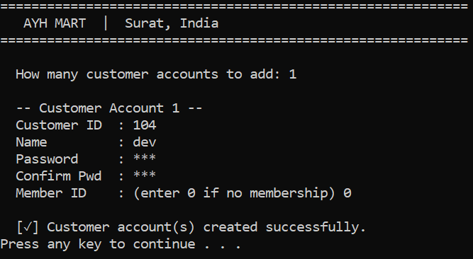
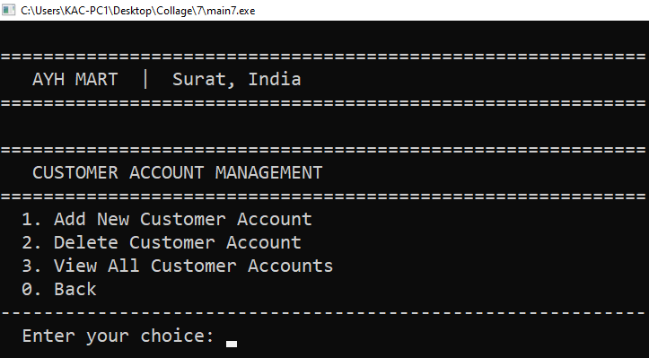
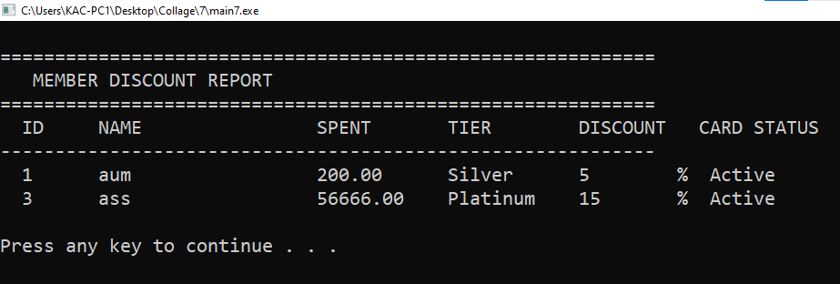
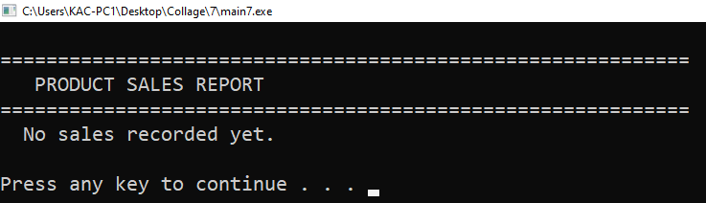
Add New Customer Account

Customer Account Management
Member Discount Report
Product Sales Report
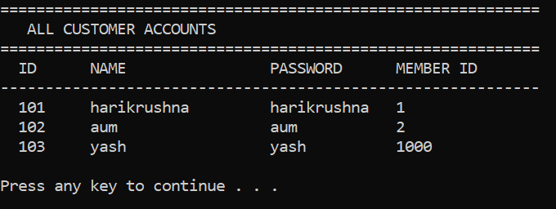
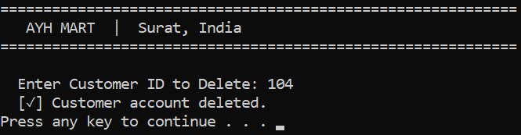
Delete Customer
View all Customer

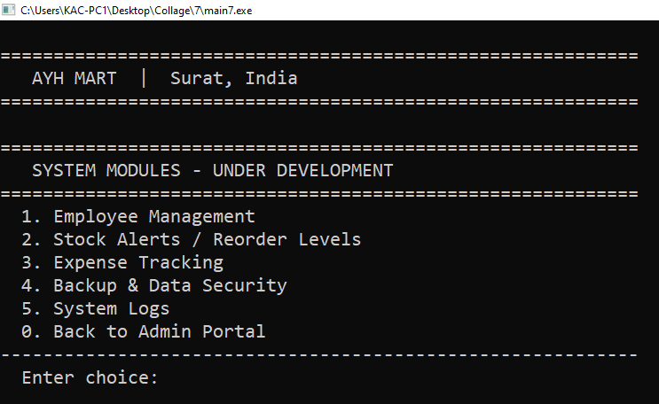
Under Development

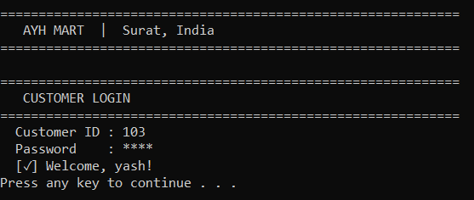
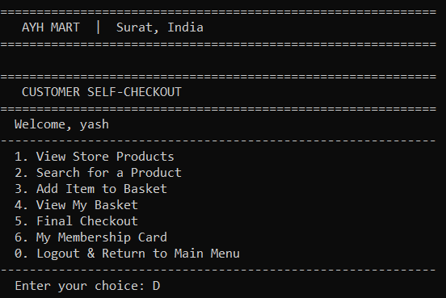
Customer Login
Customer Portal

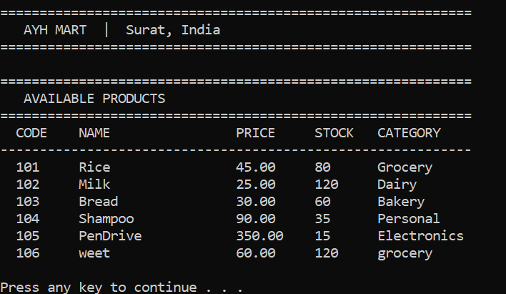
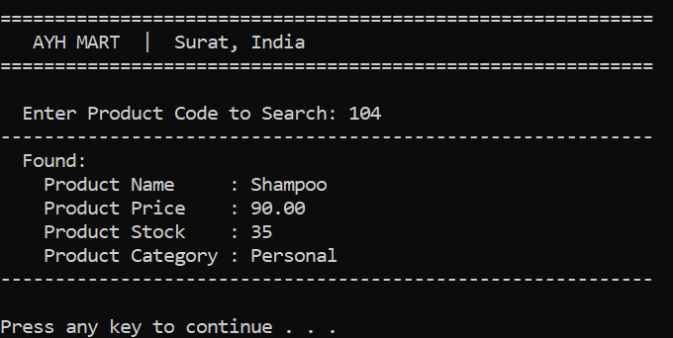
View Product
Search Product

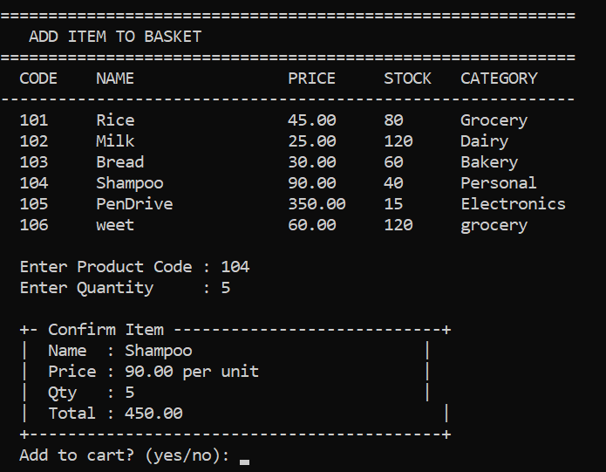
Add Item To Basket

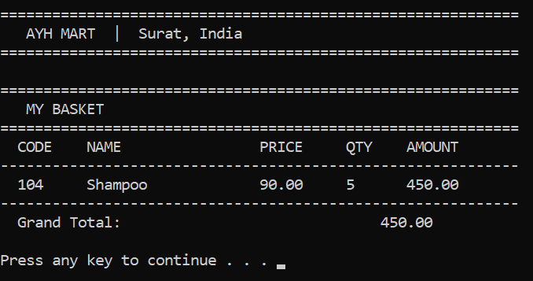
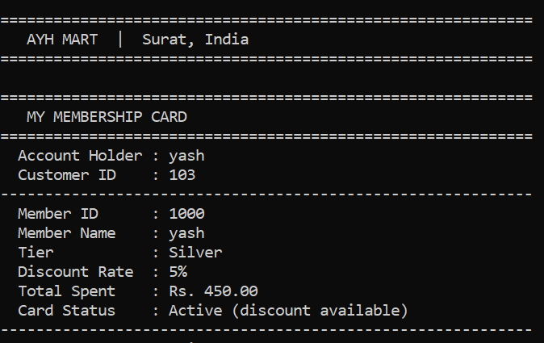
View Basket
View Membership Card

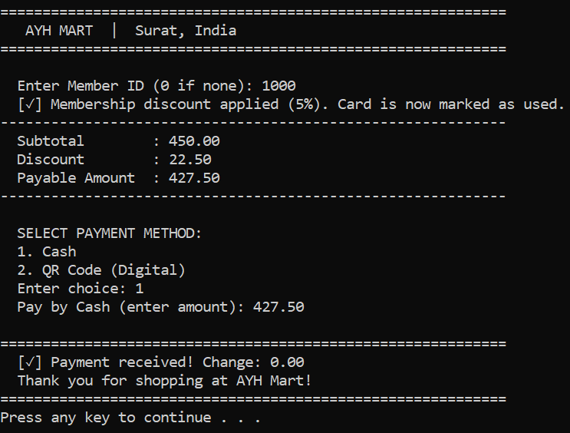
Check-Out via cash

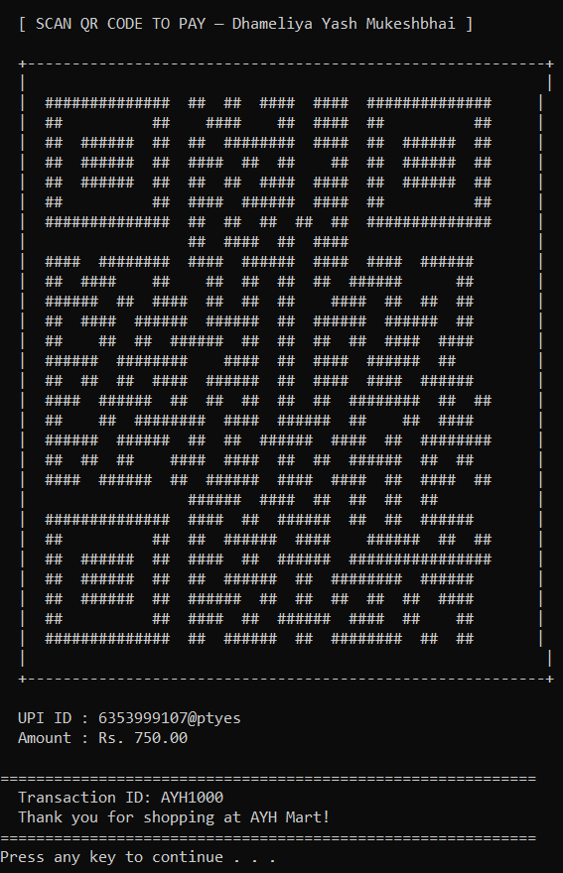
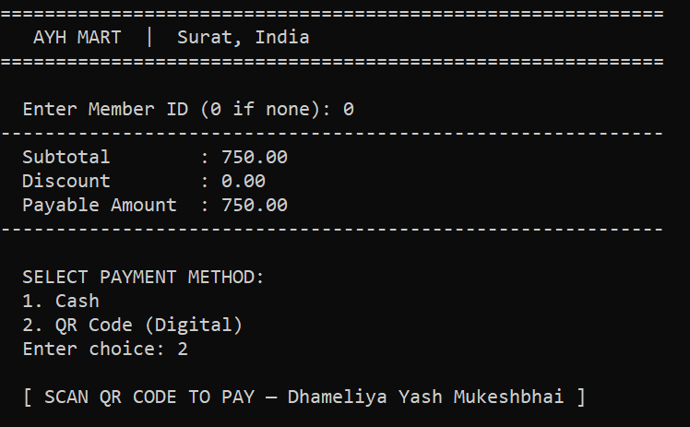
Check-Out via QR

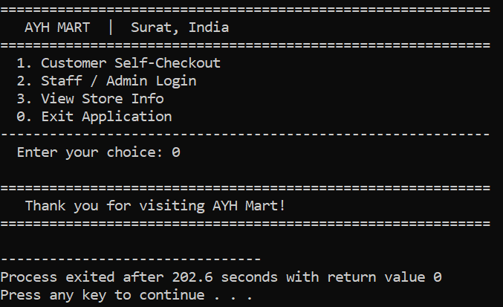
Exit Application

Testcases
1. AUTHENTICATION TEST CASES

TC ID | Scenario | Input | Expected Output | Result
TC01 | Admin login valid | admin / admin | Admin dashboard opens | Pass
TC02 | Staff login valid | staff / staff | Staff portal opens | Pass
TC03 | Login invalid | Wrong credentials | Error message shown | Pass
TC04 | Empty login | Blank input | Error / retry | Pass
TC05 | Case sensitivity | Admin/Admin | Login fail | Pass
TC06 | Password masking | Enter password | Hidden input (*) | Pass
2. CUSTOMER LOGIN

TC ID | Scenario | Input | Expected Output | Result
TC07 | Valid customer login | Correct ID + pass | Welcome message | Pass
TC08 | Invalid login | Wrong ID/pass | Error message | Pass
TC09 | No customers exist | Login attempt | Fail safely | Pass
3. INVENTORY MANAGEMENT

TC ID | Scenario | Input | Expected Output | Result
TC11 | Add product | Valid data | Product added | Pass
TC12 | Add product overflow | >100 items | Limit warning | Pass
TC13 | Edit product | Valid code | Updated product | Pass
TC14 | Edit invalid product | Wrong code | Not found | Pass
TC15 | Delete product | Valid code | Product removed | Pass
TC16 | View products | — | Product list shown | Pass
TC17 | Duplicate product code | Same code | Error message | Pass
TC18  4. MEMBER MANAGEMENT | Delete invalid product | Wrong code | Error message | Pass

TC ID | Scenario | Input | Expected Output | Result
TC19 | Add member | Valid input | Member created | Pass
TC20 | Invalid tier | Wrong input | Retry prompt | Pass
TC21 | Duplicate membership | Same customer | Error shown | Pass
TC22 | Delete member | Valid ID | Member removed | Pass
TC23 | Delete invalid member | Wrong ID | Error message | Pass
TC24 | View members | — | Member list shown | Pass
5. CUSTOMER ACCOUNT MANAGEMENT

TC ID | Scenario | Input | Expected Output | Result
TC25 | Add customer | Valid data | Account created | Pass
TC26 | Duplicate customer ID | Same ID | Error message | Pass
TC27 | Password mismatch | Wrong confirm | Retry | Pass
TC28 | Delete customer | Valid ID | Account removed | Pass
TC29 | Delete invalid customer | Wrong ID | Error message | Pass
TC30 | View customers | — | List shown | Pass
6. PRODUCT SEARCH & VIEW

TC ID | Scenario | Input | Expected Output | Result
TC31 | Search valid product | Existing code | Product details | Pass
TC32 | Search invalid product | Wrong code | Not found message | Pass
TC33 | View all products | — | Display list | Pass
7. CART OPERATIONS

TC ID | Scenario | Input | Expected Output | Result
TC34 | Add to cart valid | Code + qty | Item added | Pass
TC35 | Insufficient stock | qty > stock | Error shown | Pass
TC36 | Invalid product | Wrong code | Not available | Pass
TC37 | Cart overflow | >50 items | Cart full message | Pass
TC38 | Add item cancel | "no" | Not added | Pass
TC39 | View empty cart | — | Basket empty | Pass
8. CHECKOUT & PAYMENT

TC ID | Scenario | Input | Expected Output | Result
TC40 | Checkout empty cart | — | Warning message | Pass
TC41 | Checkout with items | Valid | Bill generated | Pass
TC42 | Cash exact payment | Exact amount | Success | Pass
TC43 | Cash extra payment | > amount | Change returned | Pass
TC44 | Cash insufficient | < amount | Retry payment | Pass
TC45 | QR payment | Select QR | QR displayed + success | Pass
9. MEMBERSHIP DISCOUNT

TC ID | Scenario | Input | Expected Output | Result
TC46 | Valid member discount | Active ID | Discount applied | Pass
TC47 | Used membership | Same ID again | No discount | Pass
TC48 | Invalid member ID | Wrong ID | No discount | Pass
TC49 | No membership | ID = 0 | No discount | Pass

10. SALES REPORT

TC ID | Scenario | Input | Expected Output | Result
TC50 | Sales summary | — | Stats shown | Pass
TC51 | Product sales | — | Sales list | Pass
TC52 | Discount report | — | Member report | Pass
TC53 | No sales yet | — | Empty message | Pass
10. SALES REPORT
11. FILE HANDLING / BACKUP
TC ID | Scenario | Input | Expected Output | Result
TC54 | Save data | Backup option | Files saved | Pass
TC55 | Load data | Restore option | Data loaded | Pass
TC56 | Restore cancel | Select NO | Operation cancelled | Pass
TC57 | Missing files | No file present | Default data loaded | Pass
12. EDGE / STRESS CASES

TC ID | Scenario | Input | Expected Output | Result
TC58 | Negative quantity | -5 | Reject input | Pass
TC59 | Large input strings | Long name | No crash | Pass
TC60 | Rapid operations | Fast inputs | Stable system | Pass
TC61 | Max limits reached | Full data | Warning shown | Pass

REFERENCES

https://www.gofrugal.com/retail/?ref=common-header

https://www.zoho.com/in/inventory/features/
OFFLINE STORE

